Step 1: Create the React + Vite Base

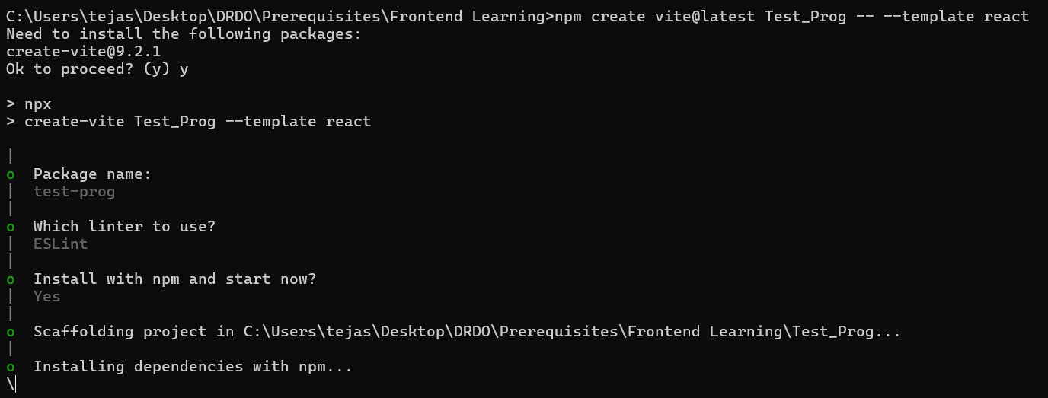
This starts basic react + vite on local host server
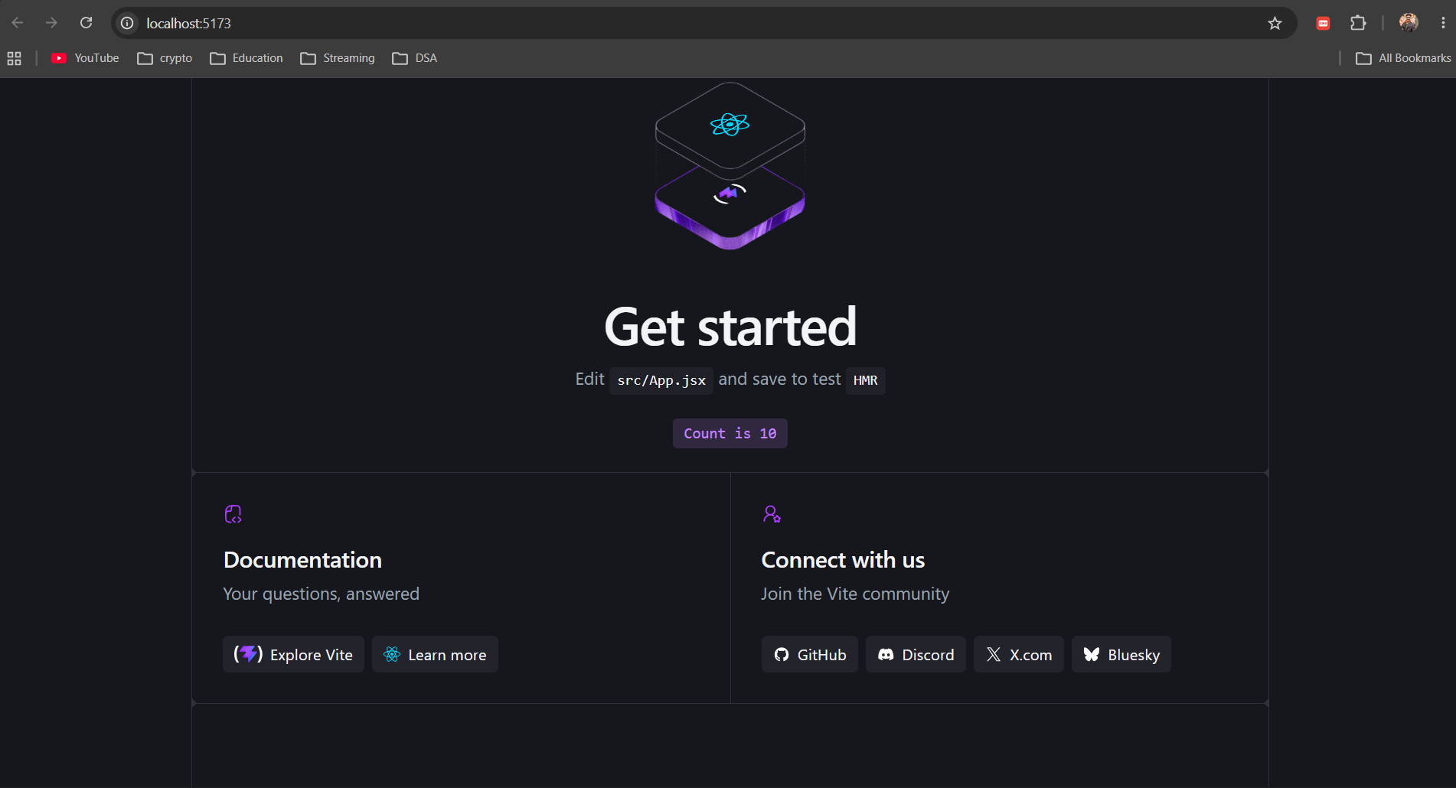

Step 2: Install Electron Tools
Install Electron alongside concurrently (runs Vite and Electron simultaneously) and wait-on (waits for the dev server to start):

npm install --save-dev electron concurrently wait-on

--save-dev : It tells npm :
These packages are needed for developing/building the application, but they aren't part of the application's runtime dependencies.

electron
This is the actual Electron framework.
Electron allows us to take our web application and run it as a desktop application.

concurrently
This package allows us to run multiple commands at the same time.
This becomes useful for your project because we need multiple things running.
For example:
React/Vite
+
Electron
+
Python backend

Normally, you'd need separate terminals:
Terminal 1 → npm run dev
Terminal 2 → electron ...
Terminal 3 → python backend.py
concurrently can help us start multiple commands together.
For example:
concurrently "npm run dev" "electron ."
Both commands can run simultaneously.
wait-on
This solves another problem. Suppose we start Electron immediately:
Electron starts
↓
tries to open localhost:5173
↓
React/Vite isn't ready yet ❌

Electron may fail because Vite hasn't started. wait-on can wait until something is available.
For example:
Start Vite
↓
wait-on
↓
Is localhost:5173 available?
↓
NO → wait
↓
NO → wait
↓
YES
↓
Start Electron
So it makes sure Electron doesn't start before the React/Vite server is ready.

Step 3: Configure Vite for Desktop File Loading
Open vite.config.js in your code editor and add base: './'. This ensures React loads assets correctly when packaged into a desktop file.

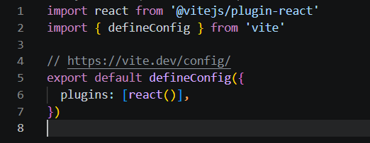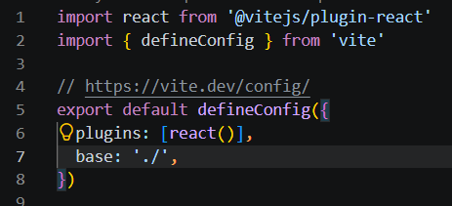
Crucial for Electron to find built JS/CSS files

Step 4: Create Electron Shell Files
Create a new folder named electron inside your main my-desktop-app directory. Inside electron, create two files:

File 1: electron/preload.cjs
File 2: electron/main.cjs

Project
│
├── React + Vite ← Frontend/UI
│
└── Electron
├── main.cjs ← Controls the desktop app/window
Electron's manager — creates the window, decides what to load, manages the application lifecycle.
└── preload.cjs ← Safe bridge between Electron and React
Secure bridge — selectively lets React communicate with Electron.

Step 5: Update package.json
Open package.json in your root folder. Add the "main" entry point and update the "scripts" block:
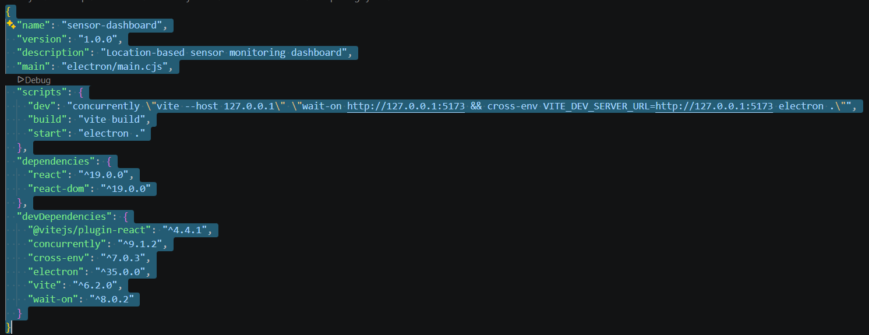
Added main for electron integration
"dev": "concurrently \"vite --host 127.0.0.1\" \"wait-on http://127.0.0.1:5173 && cross-env VITE_DEV_SERVER_URL=http://127.0.0.1:5173 electron .\"",
Step6:
Do npm install --save-dev cross-env
to install cross-env ………….then
do npm run dev
Now the react+vite webpage works on an application using electron

Creating the small application to receive data generated by the backend directly to the frontend in electron based window

do
pip install websockets
Now,
I have created a basic backend that generates data and sends to frontend using websockets and frontend will simply use that data and display it
Changes in src/app.js and backend.py created (anywhere) place doesn’t matter as it is sending data directly on frontend.
